Registration Instructions for Local Pageant Contestants:

Congratulations on becoming involved with world’s largest provider of scholarship assistance for young women. Last year the Miss America Organization and its state and local organizations made available more than $45 Million in scholarship assistance.

Beginning in 2007, Miss America developed a National Platform and has partnered with Children’s Miracle Network – an alliance of children’s hospitals. Children’s Miracle Network is a non-profit organization dedicated to saving and improving the lives of children by raising funds for children’s hospitals across North America. The 170 Children’s Miracle Network hospitals provide the finest medical care, life-saving research and preventative education to help over 17 million kids each year to overcome diseases and injuries of every kind.

This National Platform starts at the Local Pageants with the 2008 pageant year (these locals may take place in calendar year 2007 or 2008 with the winners going to the State 2008 Pageant).

How to register as a contestant of a local pageant

Each contestant is asked to register on-line at www.MissAmerica4Kids.org. At the bottom of the first screen is a button labeled “New Contestants - click here”. Press that button and you are on your way. It will take you 5 minutes or less to register. After you click the New Contestants button you will get a screen like this:

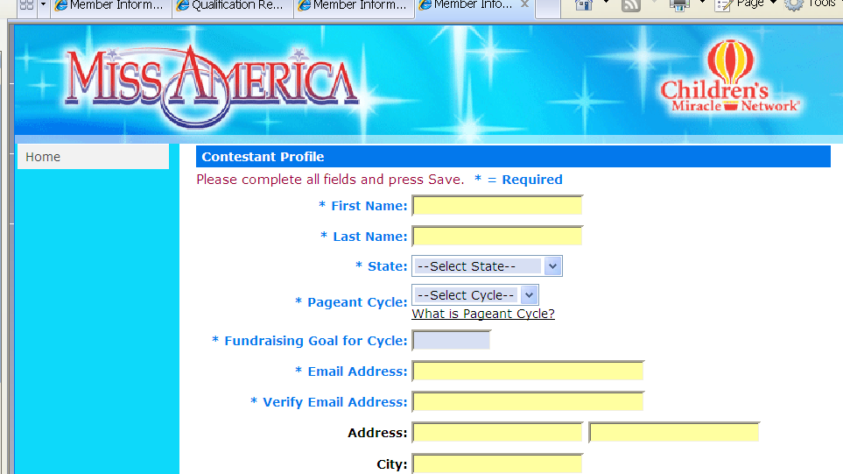
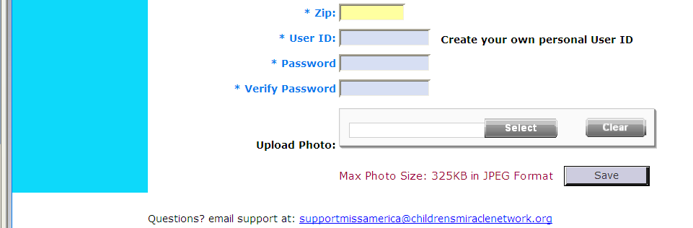
Fill it in…. and click Save at the bottom.
You get this. Look at the bottom and select the pageant or pageants you will compete in. Your fundraising goal has to align with the number of pageants you plan to enter.

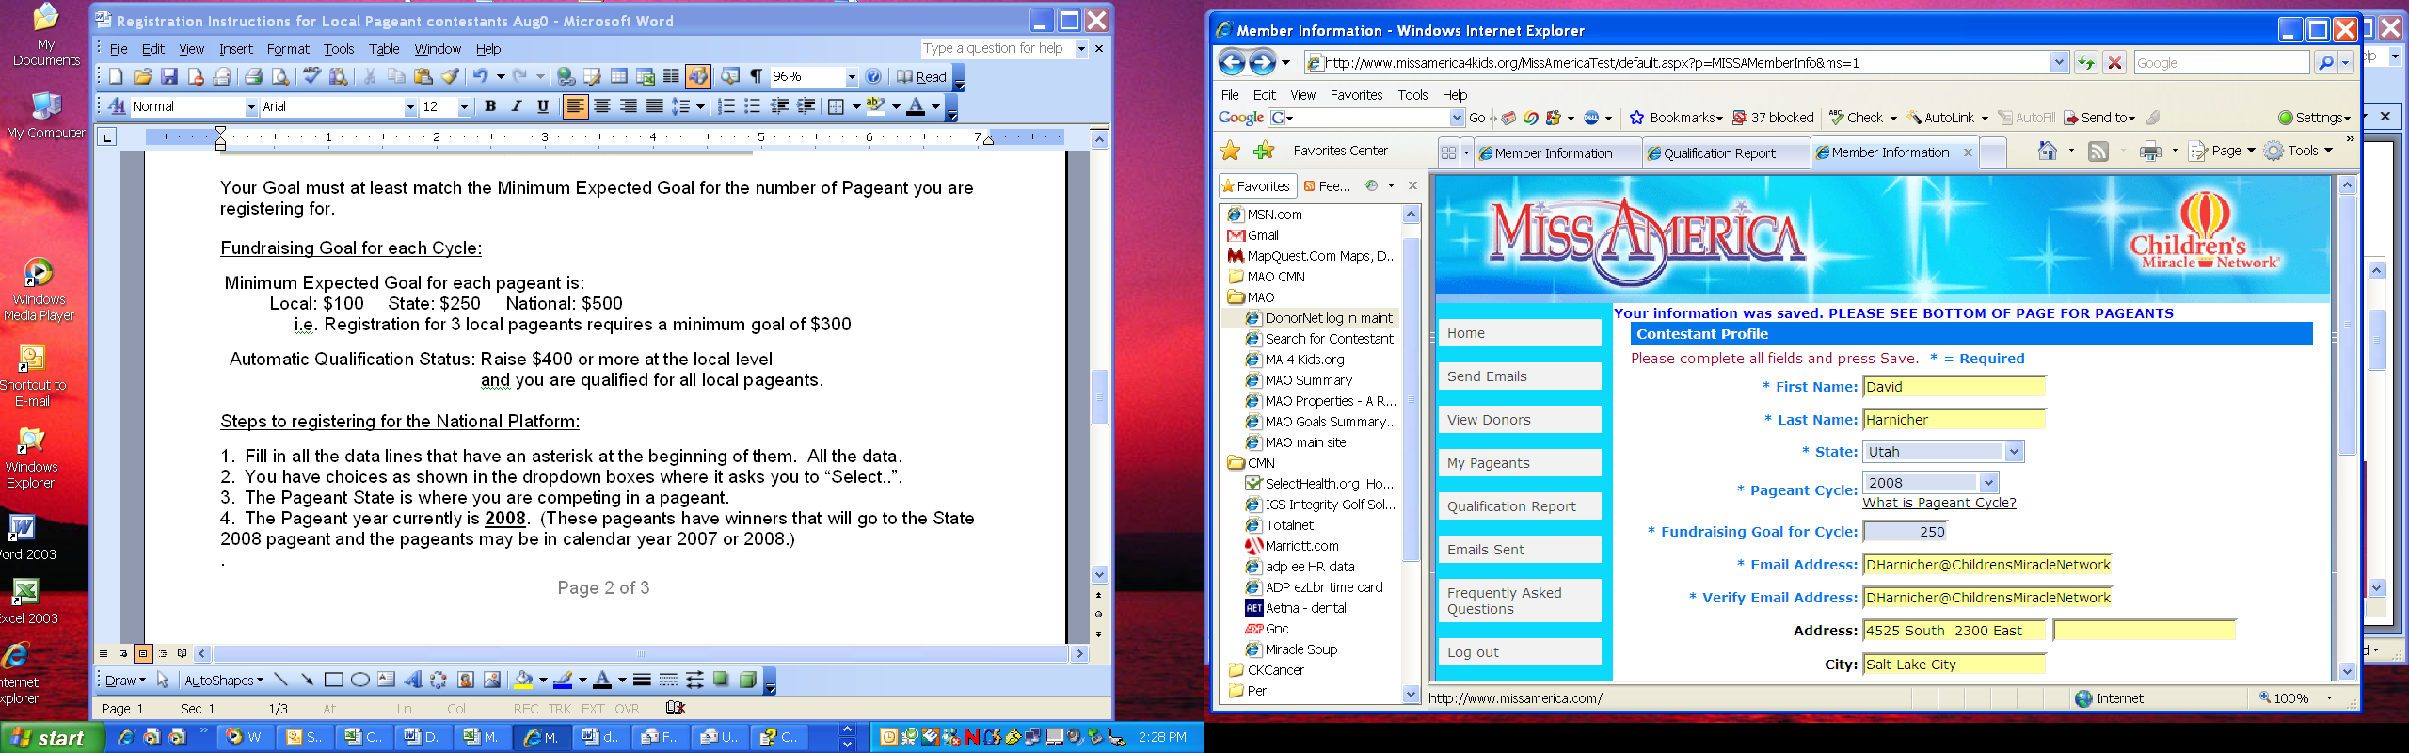
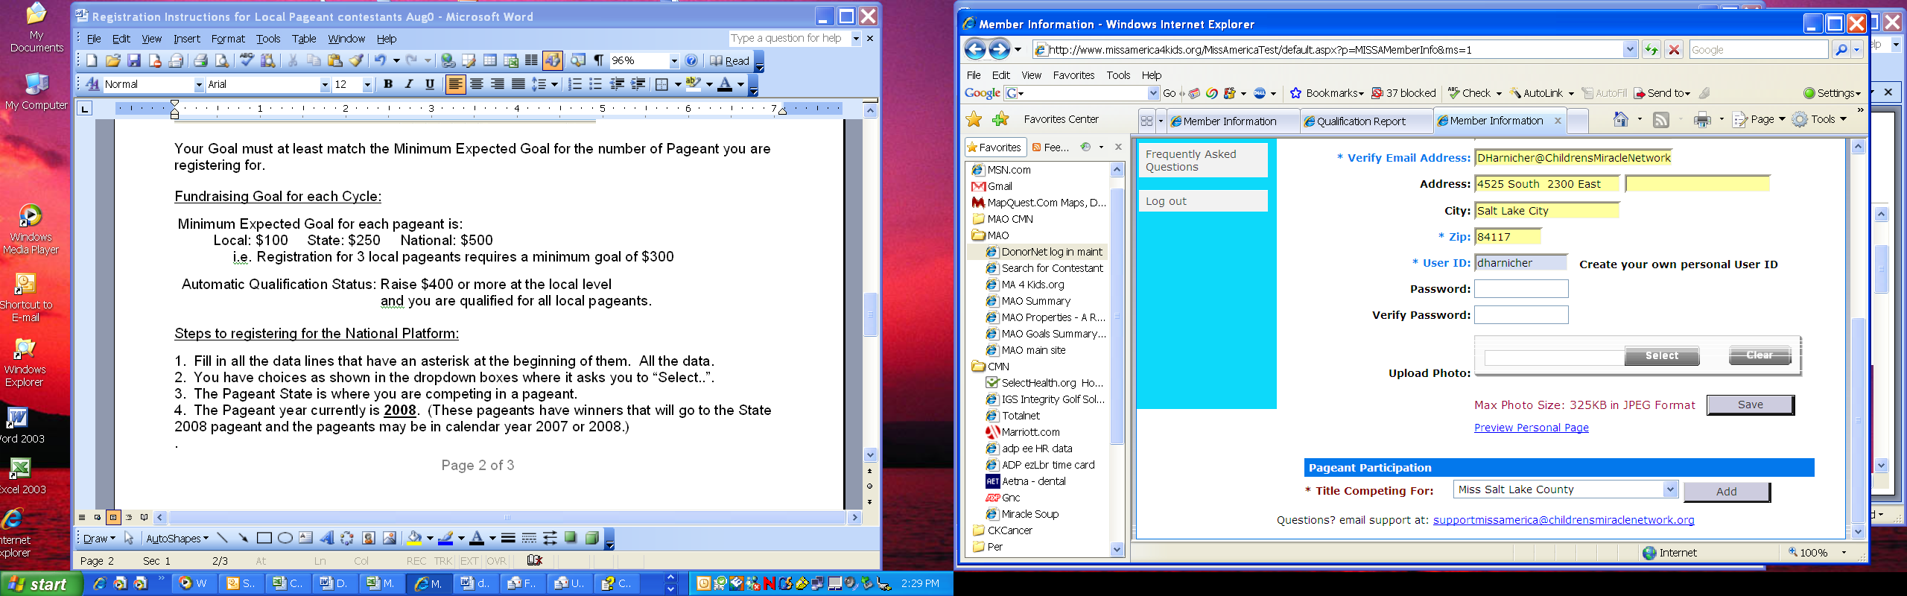

Your Goal must at least match the Minimum Expected Goal for the number of Pageant you are registering for.

Fundraising Goal for each Cycle:

Minimum Expected Goal for each pageant is:
Local: $100 State: $250 National: $500
i.e. Registration for 3 local pageants requires a minimum goal of $300

Automatic Qualification Status: Raise $400 or more at the local level
and you are qualified for all local pageants.

Once you have entered the pageants you plan to enter, you will see the pageant(s) listed.

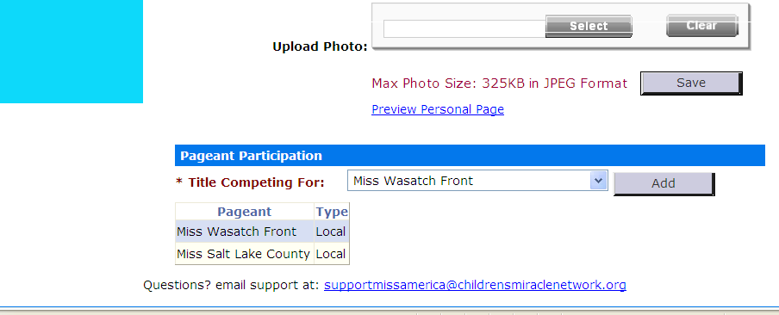

You may add pageants/change your profile when you need to, but do not change your User ID.
Steps to registering for the National Platform:

1. Fill in all the data lines that have an asterisk at the beginning of them. All the data.
2. You have choices as shown in the dropdown boxes where it asks you to “Select..”.
3. The Pageant State is the State you are competing in for a specific pageant.
4. The Pageant year currently is 2008. (These pageants have winners that will go to the State 2008 pageant and the pageants may be in calendar year 2007 or 2008.)
5. Your expected minimum goal is $100 for each local pageant level but you may select a higher goal. This minimum local pageant goal of $100 is for the National Platform with the automatic qualification available at $400 per contestant at a local pageant level.
6. Fill in everything with an * in front of the line.
7. Upload a picture (if you want to, this is optional) less than 325KB & in JPEG format.
8. Then click on Save to save the data.
9. You will get to a page that tells you that you to see bottom of page for pageants. This is where you register for the pageants you plan to enter. Title Competing For: is the title of the pageant you are currently competing for. You are asked to return to this when you enter the next pageant and change this name to the pageant that you are then competing for. You may have multiple pageants that you enter. Hit save again then so go to send emails.

10. Next, click on “Send emails” on the left hand side and enter email addresses to send to your friends and family. (Fund raising tip: send one email to yourself to your own email address, then when you get that email from the system, add a personal note to that email and forward that email to as many as you like within your own email system. You could ask for $5, $10, $20 or whatever they can give to both great causes.)
11. Print out the Qualification Report from your website and provide that printout to your ED.

The funds raised are under your name and roll-over to qualify you for future pageants within a Pageant Cycle. For example, if you raise $300 then you are pre-qualified for 3 local pageants. But, for each pageant you compete in you must update your profile on MissAmerica4Kids.org to reflect that newly entered pageant name. If you win local pageant #2, then the $100 excess ($100 was used for each of the 2 local pageants leaving $100 left over) is applied to the State Pageant minimum goal of $250. When you raise $400 during local pageant competition then you are qualified for all future local pageants within that local pageant cycle.

It is as simple as that. You may track your progress and see how you are doing. The more emails you send, the more funds you raise for both of these great organizations. Yes, these funds are for both entities – the donations help increase the future scholarship fund at the Local, State and National Levels, as well as go to supporting the children’s hospitals.

So, please take 5 minutes and go to MissAmerica4Kids.org and register for the pageant you will be competing in. If you elect to compete in additional local pageants simply return to MissAmerica4Kids.org and update your pageant you are competing in (select the next pageant you are entering). Good luck and enjoy the priceless experience you will have.

If you have questions please contact:
David Harnicher, MBA Development Associate for MAO Children's Miracle Network
(801) 273-3269 Office Cell (801) 828-8877 dharnicher@childrensmiraclenetwork.org
Children's Miracle Network | 4525 South 2300 East | Salt Lake City | UT | 84117
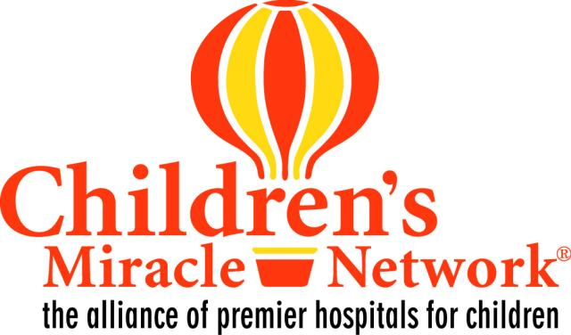
120507

